**Lab 8_2. JavaScript. Catch number game.**

**Task 1.**

**The graphical interface should be look like:**

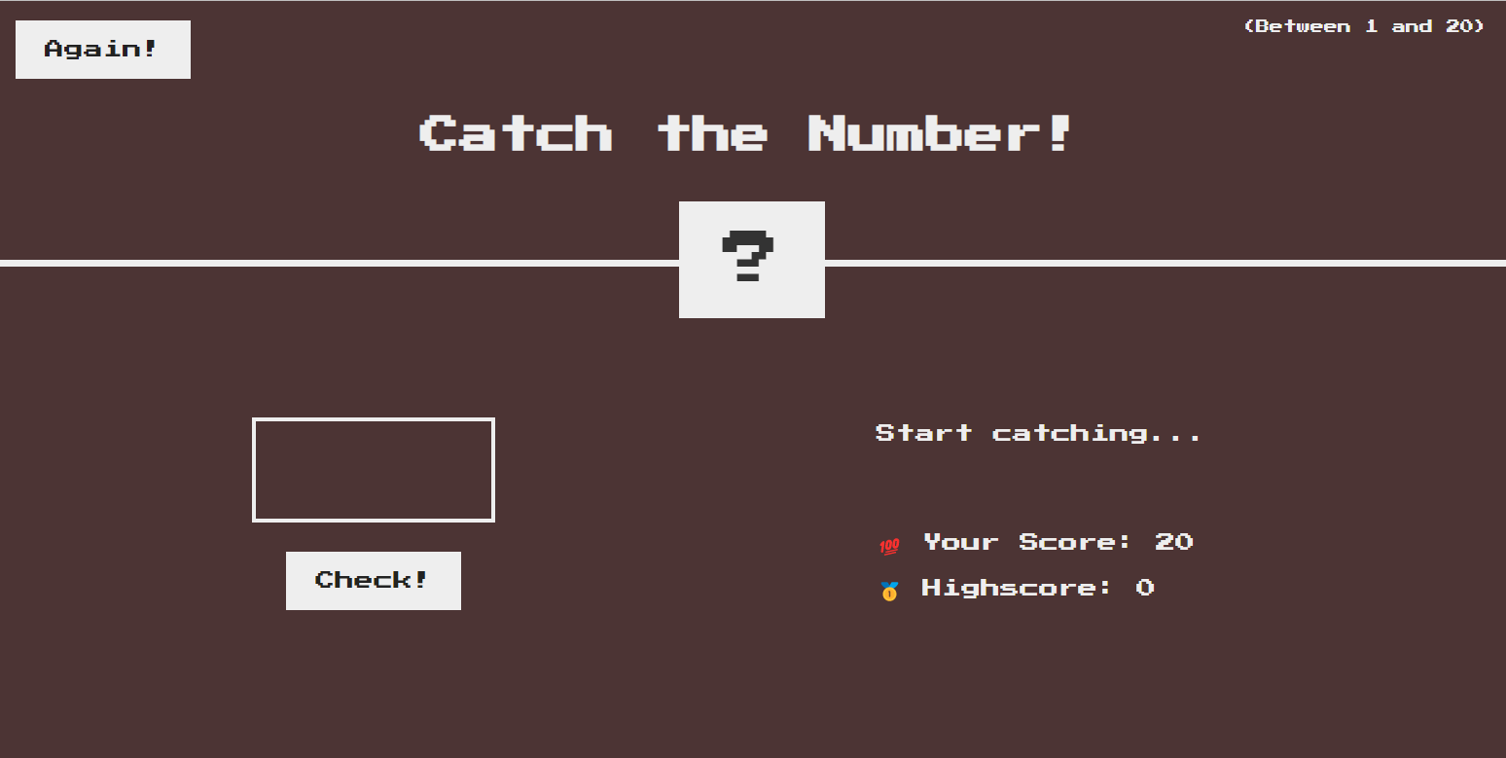

**If you catch the right number, the result will be next:**

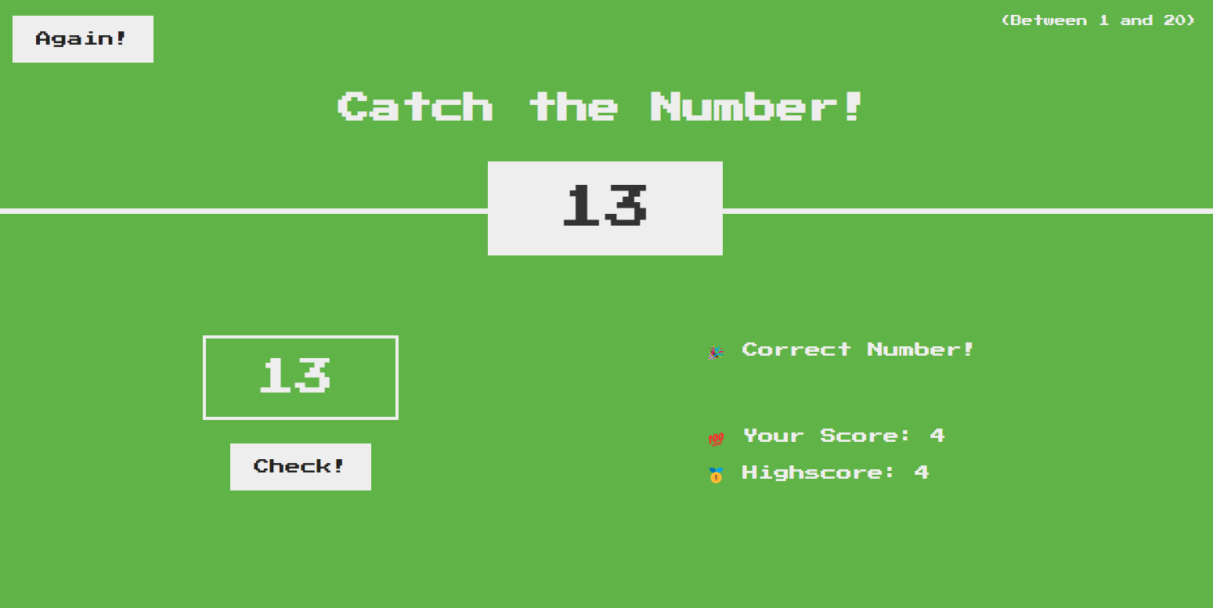

**HTML part:**

Create header and headings and paragraphs to display information text.

Create button “Again” to restart your game.

Create block element for questioning sign.

Create input field for type number.

Create button for “Check” check your result.

**CSS Part:**

Create all necessary styles for html class elements, for example: html, body, header, main, etc.

**JS Part:**

Create a **secretNumber** variable that randomly vibrates an integer from 1 to 20.

Write a function named **checkNumber()** in script.js which has 1 parameter:

• **num** is the number that the user entered in **input**.

In the center of the screen there should be a box with a question mark, this is a hidden number. When the user catches a number, it is necessary to display the hint text, the number of moves. When the user caught the number, you need to show his **highscore**. For example, if the user catches the correct number after 3 attempts out of 20, the **highscore** should be 17. If the user does not catch the correct number before the number of catches exceeds the total number of catches, the **highscore** should be 0 and the game should stop.

You need to make a button that calls the **checkNumber()** function. The **checkNumber()** function is needed to read the data entered by the user. There is also a hint text, it should reflect what the user entered earlier:

• If the user makes his first catch, the hint should read "Enter a number"..

• If the user previously caught a number that was <**secretNumber**, the hint should read "Too low!.", if > **secretNumber**, then the hint should read "Too high!",

• If the user enters an empty string or a string that is not a number, the prompt should read "Please enter a number." and give the user another chance to enter another number without losing a move.

• If the user clicks "**Again**", when he clicks, you need to restart the game, but with the previous **highscore**.